PNT2022TMID49260

DATE

12 NOVEMBER 2022

TEAM ID

UI to Display the temperature and humidity

|  |  |
| --- | --- |
| DATE | 12 NOVEMBER 2022 |
| TEAM | PNT2022TMID26841 |
| PROJECT TITLE | HAZARDOUS AREA MONITORING FOR INDUSTRIAL PLANT POWERED BY IoT |

Temperature and humidity

HAZARDOUS AREA MONITORING FOR

INDUSTRIAL PLANT POWERED BY IOT

OJECT NAME

PR

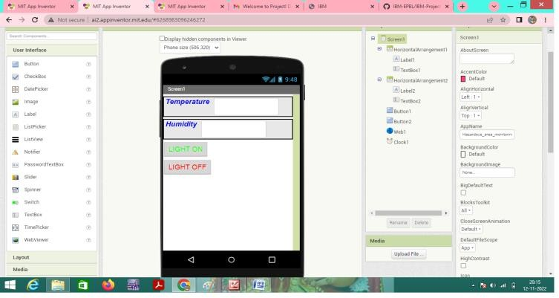

UI to display the temperature and humidity is creating successfully